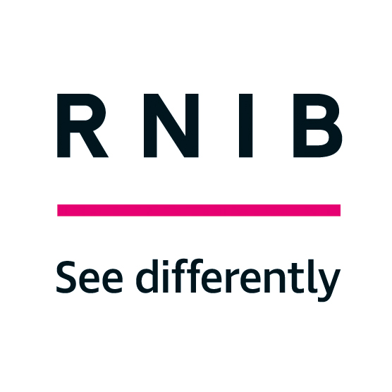

RNIB Technology Grant application form

Section 1 - Details of the person seeking a grant
Please write or type your answers in the right-hand column of the table below.

1.1 Basic details
Title
First names
Last name
Date of birth
Address excluding postcode
Postcode
Which one of these are you registered as with your local authority: blind (severely sight impaired) or partially sighted (sight impaired)?
Other disabilities

Daytime telephone number
May we leave a message on this number?
Email address
What is your preferred format? Email, Print, Large Print, Braille or Audio CD?
If you said Large Print, what font size is best for you?
How would you like us to let you know about our decision on your application: notification in your preferred format or by phone?

1.2 Your name if you are applying on behalf of your child
Title
First names
Last name
Your relationship to the child?

Section 2 - Details of what you want a grant for

2.1 The items
Please list the items you are interested in a grant for in the table below.
- This should include make and model number, and perhaps RNIB’s product number where relevant.
- Remember that the items must be reasonably priced for your needs. Please note our maximum amounts below.

The table has three columns: the left column for the type of item, the middle column for details of the item, and the right column for the cost.

Item | Details of item (make, model, supplier, catalogue number) | Cost
Talking phones, accessible smartphones, accessible tablets and e-readers (£400 maximum) |  | £
Big button or talking landline telephone and accessibility accessories (£100 maximum) |  | £
Computer accessibility software (£500 maximum) |  | £
Electronic Braille Displays and note takers (£500 maximum) |  | £
Portable handheld video magnifiers (£500 maximum) |  | £
DAISY players and USB players (£300 maximum) |  | £
Smart home devices and accessories (£150 maximum) |  | £
Wearable technology including health and fitness devices (£200 maximum) |  | £
Voice recorders and dicta phones (£150 maximum) |  | £
Accessible kitchen equipment including talking microwaves, talking scales and talking measuring jug |  | £
Talking watches and clocks (£80 max) |  | £
RNIB’s Penfriend 3 labelling device plus any spare labels and Talking colour detectors |  | £
Total | (Maximum of £500 | £

2.2 How much are you, or other organisations and people contributing towards the cost of the item(s)?
Please write or type the name of the organisations or other people in the left column and the amount they are contributing in the right column. This section is to be completed if the item(s) cost more than we are able to fund.

Name of organisation or person | Amount
 | £
 | £
 | £
Total | £

2.3 How your grant will be paid if you are successful
If the item you need help with is something that RNIB sells, we’ll supply the item direct to you if the item is in stock. Delivery of items is usually within 2 weeks of the grant being awarded.

For any items RNIB do not sell, we can transfer the grant funds into your bank or building society account.

Payment into your account can take up to 2 weeks from the time we make our decision. If we need to send the funds to your bank, we will contact you to ask you for your bank details.

Section 3 – Your benefits and savings

3.1 Which means-tested benefits do you receive?
Please indicate in the table below which of the means-tested benefits you, your partner or the child’s parents (if you are applying on behalf of a child) receive. We do not require the amount of each benefit you receive on this form. Remember to send us proof of any one qualifying benefit entitlement letter.

Means-tested benefit | Applicant receives it? (Yes or no) | Partner or parent receives it? (Yes or no)
Council Tax Support from your local authority
Income-related Employment and Support Allowance
Housing Benefit
Income Support
Income-based Job Seeker’s Allowance
Pension Credit
Universal Credit

3.2 How much do you have in savings?
Household savings | £

Section 4 – Funding from your local authority
Your local authority may be able to help with the items you need, so we ask that you contact them before applying to us. Their help could include:
- providing equipment or adaptations that your local social services have assessed you as needing (for example, in England your local social services should provide you, for free, any equipment or adaptations that cost less than £1,000)
- local welfare schemes providing essential household items
- giving you a disabled facilities grant to pay for adaptations to your home.

Which one of the following statements best applies to you?
- I have not contacted my local authority at all yet.
- I have contacted my local authority and could not get any financial assistance or equipment.
- I have contacted my local authority and was given financial assistance or equipment, but it wasn’t everything I needed.
- I have contacted my local authority and am awaiting their decision.

Please write or type the number of the statement that applies to you:

Section 5 – Details of the person supporting your application

Please provide details of the person supporting your grant application, who will need to do a letter of support for you.

5.1 Contact details of person supporting your application

Full name
Job title
Organisation
Address including postcode
Telephone number
Email address

5.2 Your supporting letter
The person supporting your application to us must write a letter of support for you

The letter must be on their official letterhead, must be signed by them and should include:

- Confirmation that you are registered blind or partially sighted
- confirmation of the make, model and price of each item being supported and that you need the item(s) you are applying for and that, if the items are replacements, your existing items are beyond repair or unsuitable for your needs
- what difference the item(s) would make to your life
- that you have been unable to get the item, or help with the cost, from your local authority
- if you are applying for access technology (such as software, video magnifiers and mobile phones), that you have tried out the items and that they are suitable for your needs
- if you are applying for a mobile phone, that you are able to meet the ongoing cost of using it.

Section 6 – Checklist
In the table below, please write or type “yes” in the right-hand column to confirm that you have followed all the necessary steps.

I have enclosed a copy of an official letter proving I receive a means-tested benefit
I have enclosed a letter of support
I have given details or enclosed a quote from the supplier for the items I need
I have shown in section 4 if I have tried to get funding from my local authority
I have taken a copy of my form in case it gets lost

Please let us know how you heard about our grants service:

A member of our Technology for Life Team (including our volunteers) would love to contact you a month after being awarded your grant to see how you are getting on with your Item(s). This will be an excellent opportunity for you to ask questions if you are having difficulties. Would you like a follow-up call?

Section 7 - Mailing preferences – tell us what you do or don’t want to receive from RNIB
Please answer the below questions in the left-hand column of the table below by writing or typing “yes” or “no”. At RNIB we are committed to protecting your data and privacy. We protect any personal information you give us in writing or while you use our websites. How you answer these questions does not affect whether you will get a grant from us or not.

You can opt-out any time in the future really easily by giving us a ring or clicking unsubscribe at the bottom of any emails we send.

Would you like to receive information about the following RNIB Group services? Please indicate. Yes or No for each line
RNIB Shop and Products
News
RNIB Campaigns
Fundraising
How would you like to receive this information? Indicate Yes or No for each line.
Email
Phone
Mail
Text

Section 8 – To be read and signed by the person applying for the grant
- I authorise RNIB to store the details from this form on their database.
- I confirm that someone has read the completed form to me if I haven’t been able to read it for myself.
- I confirm that the information given on this form is an accurate statement of my circumstances and my need for a grant.
- I authorise RNIB to contact the organisations and people mentioned on this form if it’s necessary to clarify the details of my application.
- I understand that RNIB records calls for quality and training purposes.

Signature
Date

If you have any questions about your application please contact us:

RNIB Technology Grants Team
Grimaldi Building
154A Pentonville Road
London
N1 9JE

t: 0303 123 9999
e: tfl@rnib.org.uk

Updated June 2023

